1. Flash Intro

Start the project and mention some stuff about the flash intro.

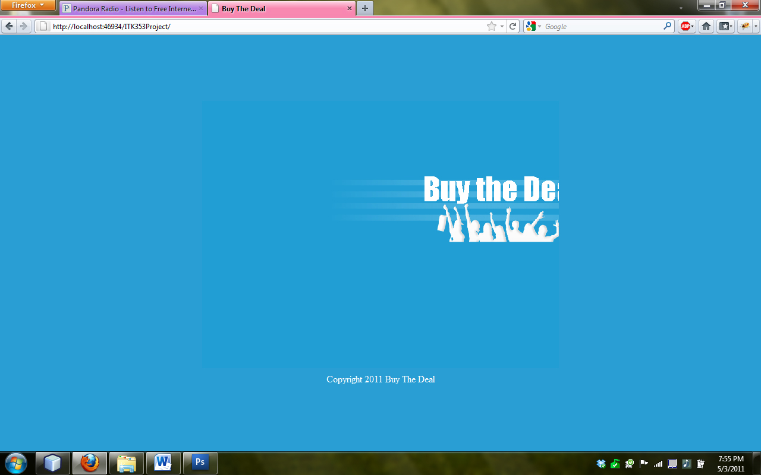

1. View the Deal-of-the-Day

Browser will be redirected to the page upon completion of the flash intro. Mention that the deal changes based on the system time and change the system time to show that it in fact does.

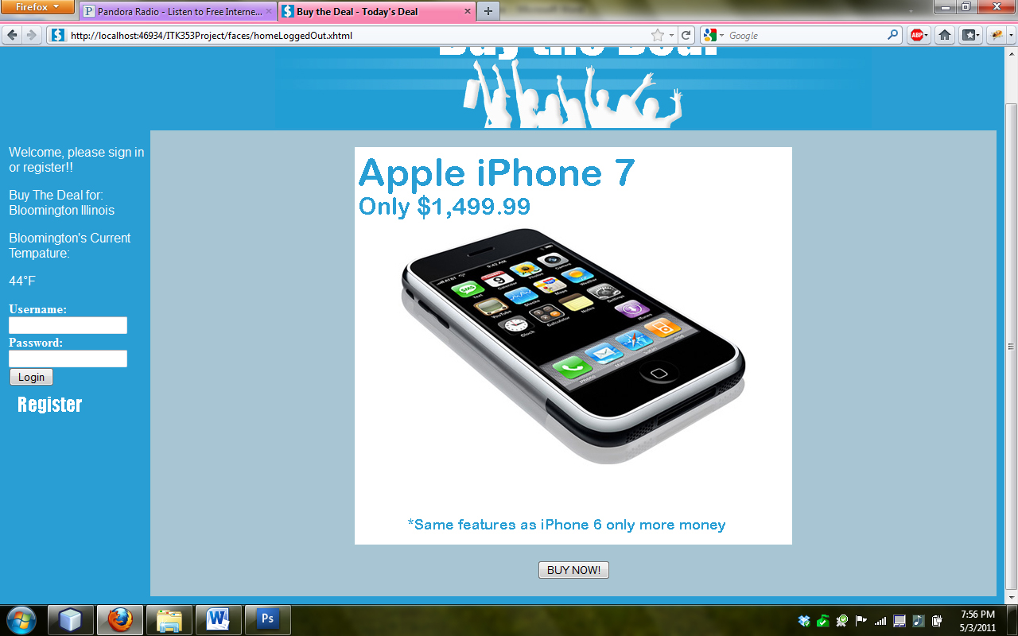

1. Current Weather Web Service

When the main page is loaded, mention that we included a web service that shows the current weather for the Bloomington area (the area that Buy The Deal operates for). Also mention that we did have a Facebook web service but because they changed their API, we had to many complications to face in order to reincorporate it.

\*See image above

1. Register User

Register a user that does not meet the validation criteria on the register page. Show that there is AJAX on the user name and that the other fields validate every time you submit the form. Show that data is not posted to the database until all the info in the form is validated. Upon doing that, register a user with correct info and show the successful database insert.

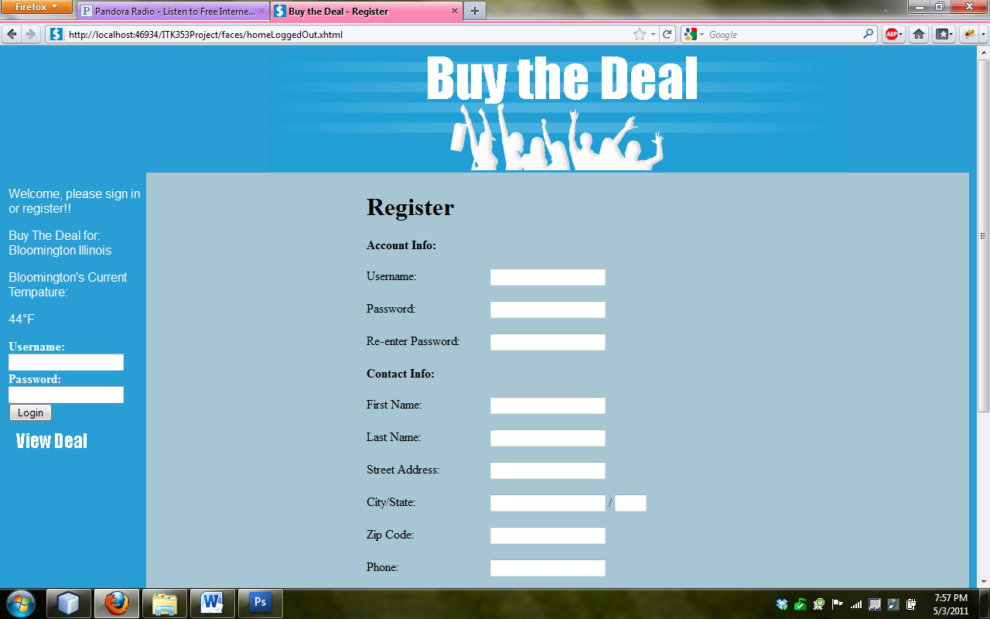

1. View/Edit My Account

Show that this use case is not an option for a user that is not logged in as web 2.0 standards dictate. After a valid log in, show that there is a fully functional manage user data page that has all of the data that they signed up with the exception of username. We will show that the user data is pre-populated into the appropriate fields using JPA. We will demonstrate that password is optionally updated and is not mandated. Also presented will be a button that will display all previous deals purchased from the site. After valid update has taken place we will show that the database has in fact been updated.

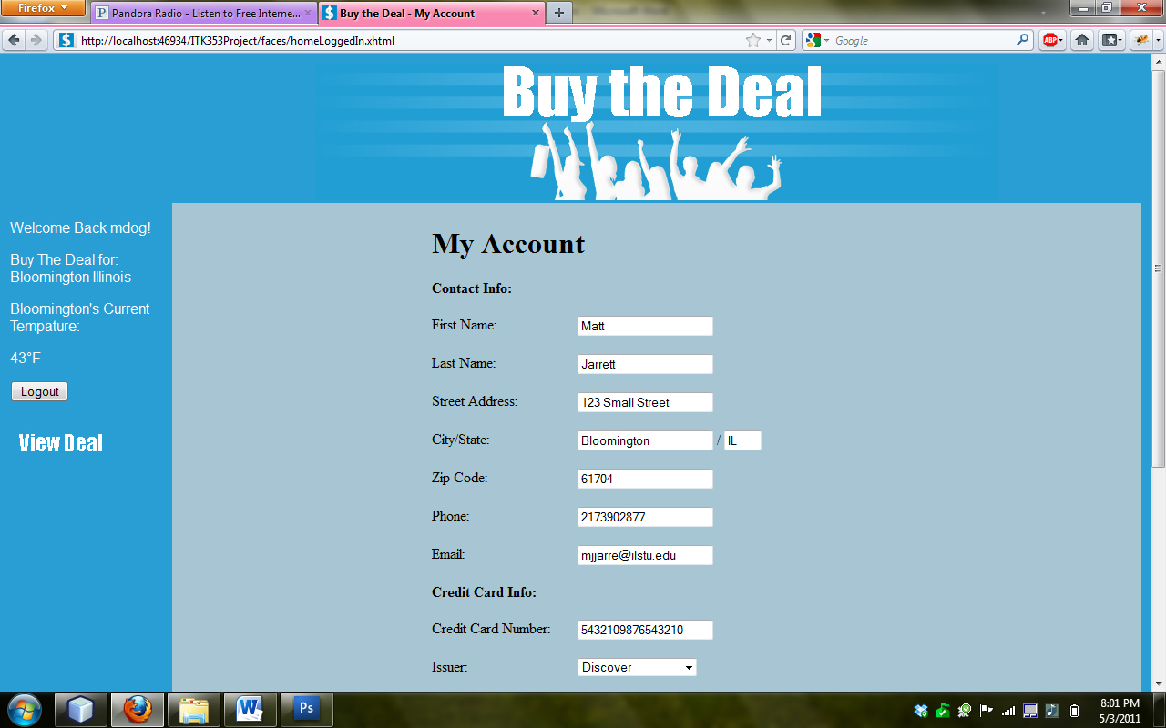

1. Sign out/sign in user

We will demonstrate that the log in function verifies appropriate username and password in order to be logged in. After a valid user is logged in we will show that the username is added to the page with a welcome back message. After the user is logged in we will show that the log in area of the site is gone as it should be. Likewise after they are logged in, there is a new button that provides logout functionality. We will demonstrate that this button ends the user session and logs them out.



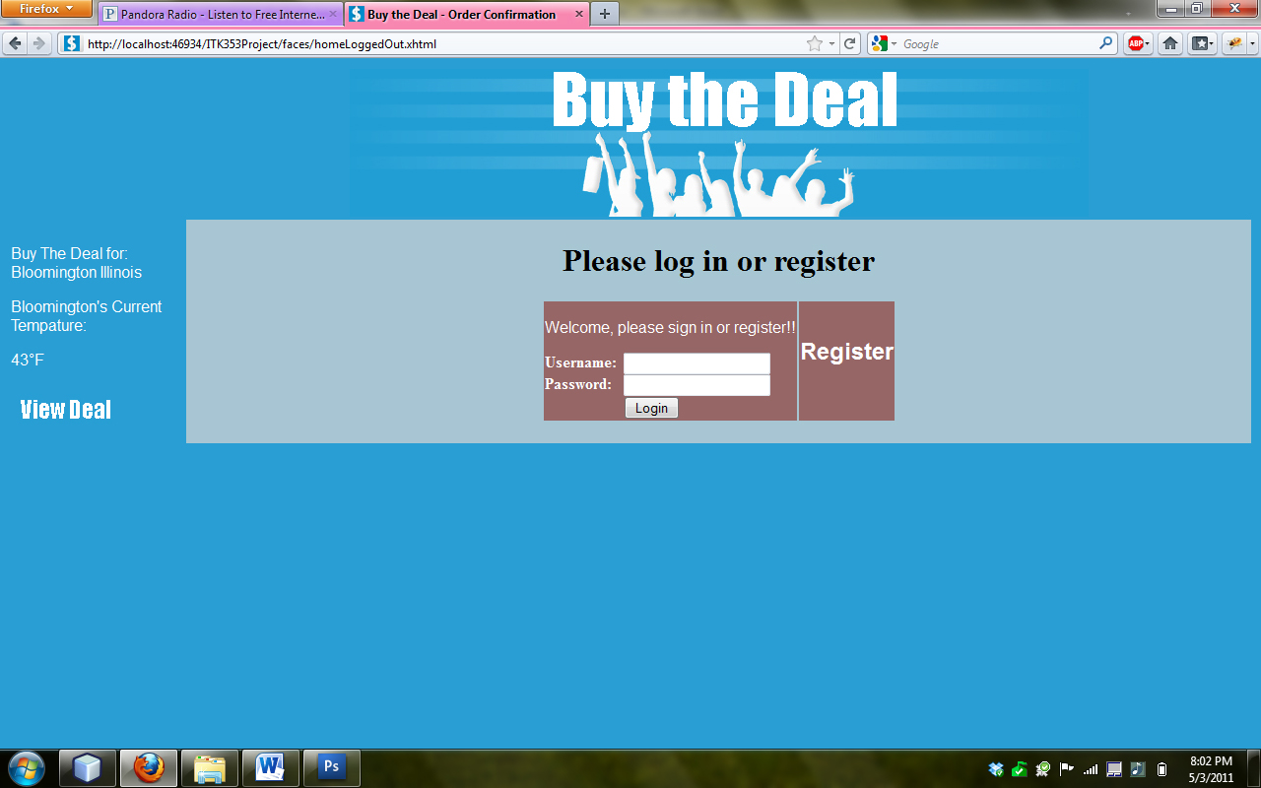

1. Purchase Deal of the Day

Show the use of the purchase use case. We will demonstrate that if the user is not logged in and clicks the buy the deal button they will be redirected to the register page (where a log in is also present if they are already registered). Once the user is logged in they will be taken to a purchase page with all of their data in fields that are pre populated showing the proper use of JPA. The user can check all of the data that relates to the purchase before purchasing the deal. Once the user clicks purchase they will be shown a purchase confirmation and told they will receive an email shortly with the purchase details.



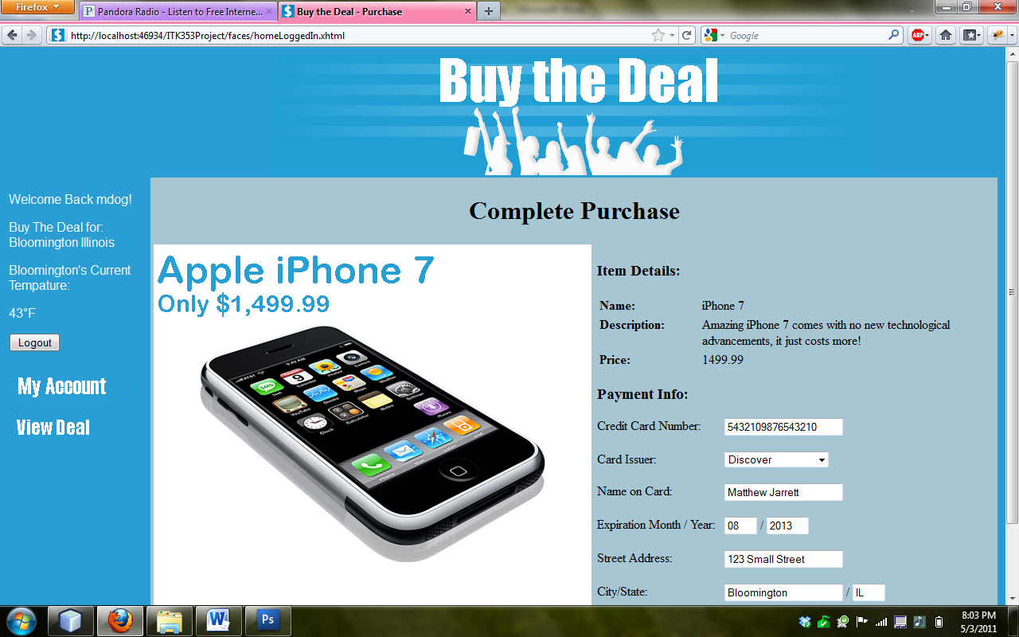

1. Email Purchase Conformation

We will demonstrate after a purchase that the web application will send an email to the users supplied email address. This email will contain all purchase data such as price and date of the purchase.

